The 2010s featured a lot of great social science. Here are my 12 favorite studies.

What economists, political scientists, sociologists, and philosophers taught me about the world in the 2010s.

Dylan Matthews (Vox)
Dec 23, 2019, 2:00 PM UTC
https://www.vox.com/future-perfect/2019/12/23/21003232/best-social-science-studies-economics-political-science-2010s

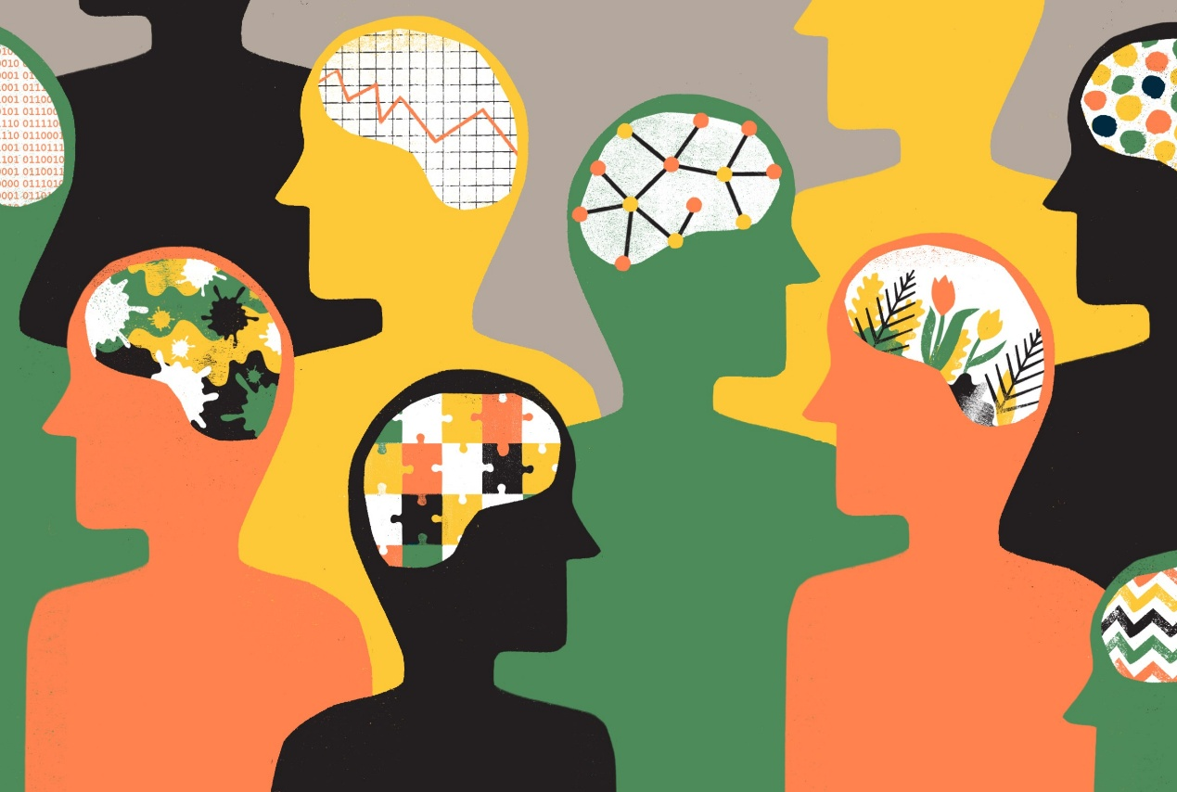

Dylan Matthews was a senior correspondent and head writer for Vox’s Future Perfect section. He is particularly interested in global health and pandemic prevention, anti-poverty efforts, economic policy and theory, and conflicts about the right way to do philanthropy.

We’re in the last month of the 2010s, and that has meant a lot of end-of-decade best-of lists on everything from movies to songs to albums to TV shows, and, at least for me, a lot of arguments with friends over whether, say, Yeezus actually holds up (it does), or if The Master or Phantom Thread is the better Paul Thomas Anderson movie (The Master), or if The Good Place is better than Parks and Recreation (it isn’t).

So I started thinking of what a list of the papers — in the social sciences like economics, political science, sociology, and psychology, but also in philosophy — that most influenced me over the 2010s would look like. Unsurprisingly, it looked like a list of ideas that have influenced my writing in Future Perfect profoundly.

The themes that run through these papers — how to conduct and synthesize scientific evidence better; how to efficiently save lives in public health; how to think about challenges like AI and the far future — are major preoccupations of Future Perfect as a section of Vox. And unsurprisingly, given my background as an American political reporter, a sizable number of these studies bear directly on the challenges US democracy is currently facing in light of furious nativist backlash politics.

I should say that this is a small fraction of the research that’s influenced me greatly this past decade, and if you’re an academic reading this and I’ve left you out, I mean no disrespect at all! I also, obviously, haven’t read everything important this decade and would love more suggestions. But here are 11 papers from the past decade — in no particular order — that have really changed how I think about the world.

1. “Free Distribution or Cost-Sharing?” (2010) by Jessica Cohen and Pascaline Dupas

I’m cheating slightly with this one; Cohen and Dupas’s article appeared in working paper form before being officially published in the Quarterly Journal of Economics in 2010. It uses a randomized experiment to show that giving away anti-malaria bednets for free dramatically increases their usage relative to charging a small, nominal fee.

This implies that charities like the Against Malaria Foundation (AMF) that facilitate the direct distribution of bednets can have huge positive effects. I’ve given thousands of dollars to AMF due in no small part to this paper, and other funders (local governments, foreign aid agencies, foundations, etc.) contributed billions more, likely saving millions of lives through decisions that Cohen and Dupas’s work influenced.

This is perhaps the single best example of how rigorous social science can make the world a dramatically better, or at least less cruel, place.

2. “Using the Results from Rigorous Multisite Evaluations to Inform Local Policy Decisions” (2019) by Larry Orr, Robert Olsen, Stephen Bell, Ian Schmid, Azim Shivji, and Elizabeth Stuart

The Cohen/Dupas paper is in some ways the best possible case for randomized trials being valuable. This paper, published this past spring, is the best counter case I’ve seen.

Focusing on education, this team of researchers tries to use average results of education policies, as measured by big randomized trials held in different locations, to predict the results in individual locations. They find that this doesn’t work very well at all: you can’t just take average results and expect that the same effect will hold in your specific case. It’s a challenging result for evidence-based policy and one I’m still grappling with.

3. “Understanding the Average Impact of Microcredit Expansions: A Bayesian Hierarchical Analysis of Seven Randomized Experiments” (2019) by Rachael Meager

This one might sound a little technical (and, to be honest, it is a little technical — Meager wrote a more accessible summary here) but it’s exciting both because of what it does and for the model it provides for other papers in the future.

One of the hardest problems in social science is that of “external validity”: Does a study conducted in one place generalize to other places? Does say, distributing bednets for free work well just in the parts of Kenya where Cohen and Dupas did their experiment, or does it work in all malaria-affected countries? Will a charter school chain that appears to deliver higher test scores in Boston work in Houston? This is exactly the problem that paper number two above found to be so serious in education policy: results don’t always generalize.

Meager’s paper, circulating since 2016 and finally published this year, is groundbreaking because it offers a way to predict how well study results will generalize. What matters, she notes, is not the fact that results of interventions will differ from place to place. Of course they’ll differ. “The relevant question is not whether the effects vary across settings but by how much they vary,” she writes in her summary.

So Meager uses techniques from Bayesian statistics to measure how much the results of a specific intervention — microcredit or microfinance programs for the global poor, of the kind offered by groups like Grameen or Kiva — vary from study to study. She doesn’t have a huge number of studies to go on (only seven) but she’s able to use this method to find that the effectiveness of microcredit varies a bit, but not a huge amount, from place to place. That suggests our evidence on microcredit is reasonably externally valid: The results in a new location are likely to resemble the results in past locations pretty closely, if hardly perfectly.

Overall, this is a hugely promising new way to synthesize evidence in emerging social science literature. Meager’s research along with the work of David Roodman synthesizing evidence on issues like incarceration and immigration, gives me hope that we’re getting better at blending knowledge across studies to come to a more complete understanding of the world.

4. “Does School Spending Matter? The New Literature on an Old Question” (2018) by Kirabo Jackson

Meager’s work correctly suggests we should focus more on syntheses of studies than specific individual studies, and this is one of the best of the latter camp I saw this decade. In this review (ably summarized here for folks without NBER access), Jackson walks through 13 recent papers, many coauthored by Jackson himself, that use highly rigorous near-random methods to measure the influence of money on school outcomes.

It’s a very basic question — does pouring more money into public schools improve outcomes? — and the answer, Jackson finds in the research base, is yes. It’s a good model for reviewing an evidence base, and a paper that’s genuinely changed my mind on the topic. I previously thought per-student funding didn’t matter much; I now think it matters a great deal.

5. White Backlash: Immigration, Race, and American Politics (2015) by Marisa Abrajano and Zoltan Hajnal

White Backlash is one of those books published before the 2016 elections that started to feel sharply prophetic as Donald Trump won the Republican nomination and then the presidency. Three years after the defeat of Mitt Romney led to speculation of a new durable demographic majority for Democratic presidents, Abrajano and Hajnal presented a detailed, quantitatively rich counterargument.

Whatever support Democrats drew due to the browning of America, they argued, would be offset by white defection from the Democratic Party precisely because of white discomfort with gradually becoming a minority group in the United States.

The 2010s saw plenty of other crucial scholarship on the persistent role of race in American politics, like Ashley Jardina’s White Identity Politics, Michael Tesler’s Post-Racial or Most-Racial?, and Cornell Belcher’s A Black Man in the White House, and other excellent studies of the American white working class’s rightward turn, like Katherine Cramer’s The Politics of Resentment and Arlie Russell Hochschild’s Strangers in Their Own Land. But Abrajano and Hajnal blended the two topics, and centered the key role of immigration specifically, in an admirably comprehensive way.

6. “Democracy for Idealists” (2016) by Niko Kolodny

It’s easy to construct a narrative in which democracy in the United States is eroding. The Supreme Court declined to challenge state efforts to rig elections through gerrymandering; some 17 million voters were purged from the rolls from 2016 to 2018, and government decisions correlate poorly with public opinion as measured in polls.

The 2010s also saw lots of political science suggesting that democracy was not just eroding but that the individual-level prerequisites for its success — informed, rational voters — did not exist. Voters, political scientists Donald Kinder and Nathan Kalmoe concluded, are not ideological and do not have stable political beliefs; they tend to take their cues from elites rather than vice versa, Gabriel Lenz found; they make irrational inferences about candidates based on economic conditions those candidates have no control over and vote on irrelevant factors like shark attacks, Larry Bartels and Christopher Achen argued (to some pushback).

Kolodny, one of the leading political philosophers currently working on questions of democratic theory, quietly posted an article a couple of years ago walking through this literature and trying to determine what, exactly, should trouble us about it and what shouldn’t. Voter ignorance is not a dire threat to democracy, he argues, nor is a lack of “responsiveness,” which he convincingly suggests is an incoherent ideal.

What worries him most are concerns about the distribution of political influence: the fact that some Americans’ access to political influence is far greater than that of other Americans. This concern agitates toward an expansion of suffrage and toward resisting efforts to suppress the vote. But it makes our concern with practices like gerrymandering harder to articulate.

I don’t agree with all of what Kolodny says here. But he is one of the only people I’ve seen to try to take this literature seriously and think about the ethical and philosophical implications of it. Anyone even mildly concerned about the fate of American democracy should read it.

7. “The Coalition Merchants” (2012) by Hans Noel

If public opinion doesn’t determine the future of public policy, as the studies limned by Kolodny suggest, what does? Here, Noel tells a compelling story that places “coalition merchants” — party activists, sympathetic journalists, and other ideologues — at the center, deciding “what goes with what” and what it means to be a conservative or a liberal.

He illustrates this using race relations in the 1950s and 1960s; he argues that intellectuals like William F. Buckley and groups like Americans for Democratic Action were crucial in identifying support for government services with support for civil rights.

8. “Valuing the Vote: The Redistribution of Voting Rights and State Funds following the Voting Rights Act of 1965” (2014) by Elizabeth Cascio and Ebonya Washington

This one was neck and neck with another of Washington’s papers, “Why Did the Democrats Lose the South?”, in which she and Ilyana Kuziemko show that ethnocentric attitudes among Southern whites, apart from any economic processes, wholly explain the defection of white Southerners from the Democratic Party in the wake of the civil rights movement.

That paper, like Abrajano and Hajnal’s book, underlined the severity of white backlash to demographic and rights-based shifts in the power of non-white ethnic groups. But Washington’s paper with Cascio tells a more hopeful story, of what can happen when a disadvantaged ethnic group is finally given suffrage in an authoritarian regime.

The Voting Rights Act of 1965 did a huge amount to break up the one-party states that prevailed in most Southern states after the end of Reconstruction, states which some scholars have likened to single-party dictatorships abroad. In doing so it gave black voters, and black communities as units, power over the provision of public goods that they lacked before.

Cascio and Washington found that this shift produced meaningful changes, and in particular, a marked increase in government spending. They also offer some suggestive evidence that much of these transfers went to education spending, which (as the Jackson review above suggests) likely improved the quality of instruction for black students.

The Cascio and Washington paper offers an example of how government action can bolster democracy in a sense that should be recognizable to anyone: Greater equality in access to suffrage led to greater equality in access to concrete government services. The subsequent erosion of the Voting Rights Act threatens this achievement, but the Act’s success in the first place is inspiring.

9. “Race and Economic Opportunity in the United States: An Intergenerational Perspective” (2018) by Raj Chetty, Nathaniel Hendren, Maggie Jones, and Sonya Porter

You’d have to actively try to avoid including a paper by Chetty, Hendren, and the rest of the Opportunity Insights lab at Harvard on a list like this, given how much they’ve taught us about economic opportunity, segregation, higher education, and more (I have a big soft spot for Chetty et. al. on Danish retirement savings accounts).

But Jones and Porter’s ability to link Chetty and Hendren’s massive tax records-based data set on economic prospects to census data on individuals’ races and genders allows a particularly vivid and useful analysis.

Some of the findings are depressing but unsurprising: Black and American Indian children born into upper- or upper-middle-class families are nearly as likely to fall to the bottom fifth of the income distribution as to stay in the top fifth. Upward mobility for children born into the bottom fifth of the distribution is markedly higher among whites than among black or American Indian children.

Others are depressing but surprising; conditional on their parents’ income (a big conditional, to be sure) black women outperform white women in terms of their individual earnings. This does not mean there is no income gap between white and black women (black women’s parents, after all, make a lot less on average than white women’s parents) — but it does provide strong evidence against both family structure-based and genetic explanations of racial inequality in the United States.

I could keep going, but this is a great example of using a massive dataset to bring much-needed clarity to an incredibly vital and heated topic.

10. “Cluelessness” (2016) by Hilary Greaves

The choices we make have unpredictable consequences that ripple out for centuries or millennia, by affecting life and death. This is a very technical paper (this podcast presents a more accessible version), but Greaves does a great job of explaining cases where this kind of cluelessness is fine (where we can just make our best guess as to which action will work out best) and in which cases it’s really, really troubling.

I also highly recommend Greaves’s recent paper with Will MacAskill making the case that the most important thing, morally speaking, is preserving the far-future of humanity.

11. “Occupy Liberalism! Or, Ten Reasons Why Liberalism Cannot Be Retrieved for Radicalism (And Why They’re All Wrong)” (2012) by Charles Mills

This is really a “decade achievement award” more than a specific paper, but I think Mills has been doing some of the most fascinating and vital work in political philosophy on how to take racial injustice seriously. What’s particularly fascinating about his methods is that he does not, as some Marxists and other radicals do, reject the liberal tradition wholesale. While he acknowledges and emphasizes the explicit racism of figures like John Locke and Immanuel Kant, he nonetheless has tried to develop what he calls a “black radical liberalism” that can overcome these origins.

His “Occupy Liberalism!” paper, later incorporated into the book Black Rights/White Wrongs, provides a valuable sketch of what the resulting liberalism might look like. In the process, he provides a stirring defense of traditional liberal values — like protection from unnecessary state encroachment on individual liberty — as necessary for racial justice. “Liberalism’s failure to systematically address structural oppression in supposedly liberal-democratic societies is a contingent artifact of the group perspectives and group interests privileged by those structures, not an intrinsic feature of liberalism’s conceptual apparatus,” he writes.

This is especially true when you have thinkers like Mills, Tommie Shelby, Elizabeth Barnes, Christopher Lebron, and Elizabeth Anderson working to expand that conceptual apparatus and make it hospitable to people that philosophical liberalism has not traditionally privileged.

12. Automating Inequality: How High-Tech Tools Profile, Police, and Punish the Poor (2017) by Virginia Eubanks

This is the only trade book on my list, but make no mistake: This is a rigorous, compelling piece of qualitative social science and one of the best-crafted nonfiction books I’ve ever read, period. As a journalist, it made me actively envious of its prose.

Eubanks studies three specific algorithmic systems currently used by state and county governments in the hopes of making service provision more efficient. The opening example, of Indiana’s botched eligibility system that wound up wrongfully denying access to Medicaid and food stamps to thousands of people, is pretty straightforwardly awful. But the examples of Pittsburgh’s algorithm for evaluating the severity of child abuse and neglect cases, and Los Angeles’s system for determining which homeless people should receive housing assistance, are subtler and in some ways more eye-opening.

The LA system, for instance, seems to mostly work well — except that it masks the extent to which the city’s problem is structural (a lack of housing supply and crucially a lack of funding for permanent supportive housing) rather than an issue of rationing better through better algorithms. The Pittsburgh system helps remedy a very real problem of limited child and protective services resources for addressing cases of abuse, but because the algorithm is poorly designed and is predicting the wrong variable, it risks criminalizing poverty in certain cases.

It’s an early example of the harms that misaligned AI can cause as deep learning becomes more and more capable in coming years, and a reminder of what can go awry when politicians mistake technical solutions for political solutions.

